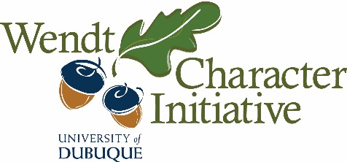
Wendt Character Initiative
Grant Request
Submission Instructions

1. Please submit the grant request form via email to Wendt@dbq.edu.
2. Funding applications should be received in the Wendt Center and approved 30 days prior to the event for which funding is sought.
3. Title your request with appropriate connections to the Wendt Character Initiative.
4. Itemize the specific expenses for which funding is sought. Funds will be released after completion of the project and upon submission of receipts as per University policy.
5. Include the following language for public announcements of grants or event introductions:
This project is supported by the Wendt Character Initiative, which is devoted to promoting a campus culture of excellent moral character and purposeful lives characterized by integrity, justice, and compassion.
6. Within 30 days of the completion of the project or event, a follow-up report assessing the effectiveness of the venture should be submitted electronically to the Wendt Center. This report includes:
- input from students as appropriate,
- at least one digital photograph suitable for inclusion in a report, and
- a one page write-up assessing intended outcomes, particularly in regard to students’ character development and/or understanding of character.
7. Be prepared to have students (or yourself) present at the spring celebration of Wendt Grants.

Questions?
Please email wendt@dbq.edu or contact Mary Bryant or Dr. Annalee Ward at 589-3440.

